AI ASSITANT CODING
ASSIGNMENT-15
M.SHIVAMANI
2303A52344
BATCH-38

Task Descriptor-1: (Setup Fast API Backend ) Instructions:
- Install Fas tAPI and Uvicorn.
- Use AI to generate a basic FastAPI application with one endpoint Sample Code:
from fastapi import FastAPI app = FastAPI() @app.get("/")
def read_root():
return {"message": "Welcome to AI-powered FastAPI"} Expected Output:
Running the server and accessing: http://127.0.0.1:8000/
Response:
{"message": "Welcome to AI-powered FastAPI"}

Prompt:-
Generate a simple FastAPI application in Python. Requirements:
- Import FastAPI
- Create FastAPI app
- Create one GET endpoint "/"
- The endpoint should return JSON message:
{"message": "Welcome to AI-powered FastAPI"}
The code should run using uvicorn and be beginner friendly.

Output:-

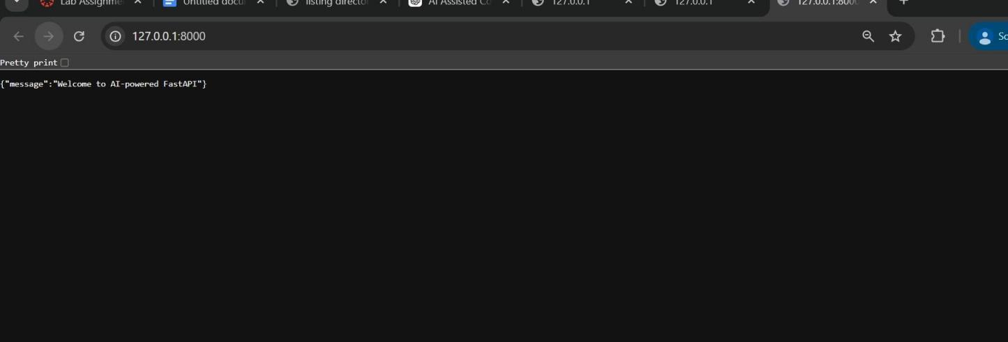

Task Descriptor- 2: (API – Create and Read Items) Instructions:
- Implement endpoints to add and retrieve products.
- Use a Python list as temporary storage. Sample Code:
items = [] @app.get("/items") def get_items():
return items @app.post("/items")
def add_item(item: dict): items.append(item)
return {"message": "Item created", "item": item} Expected Output:
GET /items → []
POST /items with {"name":"Pen","price":20}
→ {"message":"Item created","item":{"name":"Pen","price":20}}

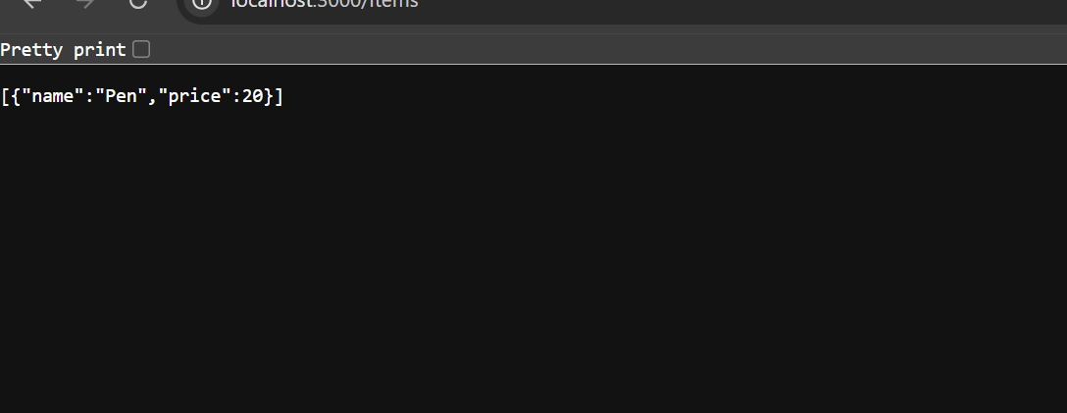

Task Descriptor- 3: (Update Existing Item) Instructions:
- Use AI to generate an endpoint to update an item using its index. Sample Code:
@app.put("/items/{index}")
def update_item(index: int, item: dict):
if index >= len(items):
return {"error": "Item not found"} items[index] = item
return {"message": "Item updated", "item": item} Expected Output:
PUT /items/0 with {"name":"Pencil","price":10}
→ {"message":"Item updated","item":{"name":"Pencil","price":10}}

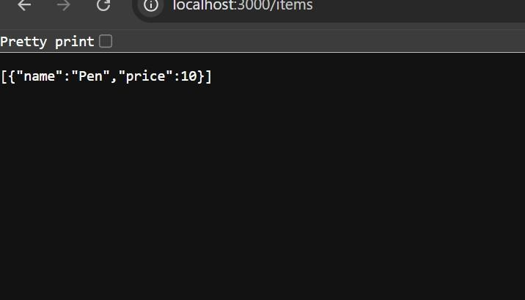

Task Descriptor- 4: (Delete Item) Instructions:
- Implement deletion of an item by index. Sample Code: @app.delete("/items/{index}") def delete_item(index: int):
if index >= len(items):
return {"error": "Item not found"} removed = items.pop(index)
return {"message": "Item removed", "item": removed} Expected Output:
DELETE /items/0
→ {"message":"Item removed","item":{"name":"Pencil","price":10}}

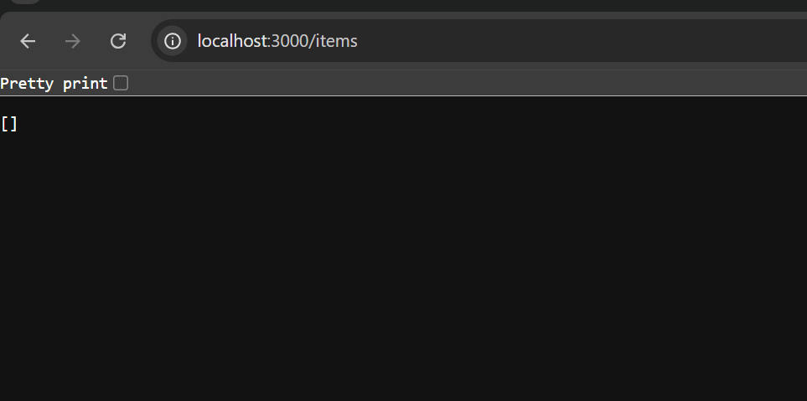

Task Descriptor -5: (Add Auto-Generated Documentation) Instructions:
- Use AI to add inline comments and docstrings for all endpoints.
- Optionally, integrate Swagger / Flask-RESTX to auto-generate API documentation.
Sample Code:
@app.route('/items', methods=['GET']) def get_items():
"""
GET /items
Returns a list of all items in the store. """
return jsonify(items) Expected Output:
- Clear documentation for all endpoints, e.g., via /docs if using Swagger.
- Students should be able to see endpoint description, methods, and sample payloads.

